**EDA COMPREHENSIVE PROJECT**

**Problem Statement:**

The modern world is shaped by complex dynamics in population, health, and economics, making understanding these trends vital for informed policy-making. GlobalTrends, a leading analytics firm, is dedicated to deciphering these patterns through a comprehensive analysis of the Gapminder dataset. Your role in this project is to conduct an in-depth Exploratory Data Analysis (EDA), uncovering the intricate relationships between demographic changes, economic development, and health advancements over recent decades.

**NOTE:** For subjective questions, explain your answer in theory with clear examples and thoughtful analysis of the reasons behind the trends.

**Dataset:** [Gapminder World](https://drive.google.com/uc?id=1fDGZh86UPUkt2K6enlNQfB0mswU8pB_P)

**Objectives:**

1. Load the dataset and display the first few rows. How many countries does the dataset have?
2. Create a pivot table that shows the average life expectancy for each continent and year. Index by 'continent', use 'year' as columns, and 'life_exp' as values.
3. Which countries had a GDP per capita higher than the 75th percentile in 2007?
4. Categorize the 'life_exp' into 4 equally ranged bins from 'Low' to 'Very High'. Use cut to create these categorical life expectancy groups and add them as a new column 'Life_Exp_Range'.
5. Identify the top 5 countries with the highest GDP per capita in 2007. Use a horizontal bar chart to display this data.
6. Find all country names that start with "I" and end with "a" using regex.
7. Create a boxplot using Seaborn to compare the distribution of GDP per capita for each continent in 2007.
8. Find all countries with a life expectancy of over 80 years in 2007. List these countries and their respective continents.
9. Convert the 'year' column to a datetime type and extract the decade. Create a new column 'Decade' that groups the years into decades (e.g., the 1950s, 1960s).
10. Compute the correlation matrix between GDP per capita, life expectancy, and population for the dataset. Then, use Seaborn to visualize this correlation matrix as a heatmap.
11. How has the global average life expectancy changed from 1952 to 2007? Plot a line graph to visualize this trend.

**Subjective Question: Discuss the various reasons that could have contributed to the change.**

1. For the year 2007, analyze the relationship between life expectancy and GDP per capita. Subjective Question: Is there a noticeable trend or correlation? Represent this using a scatter plot.

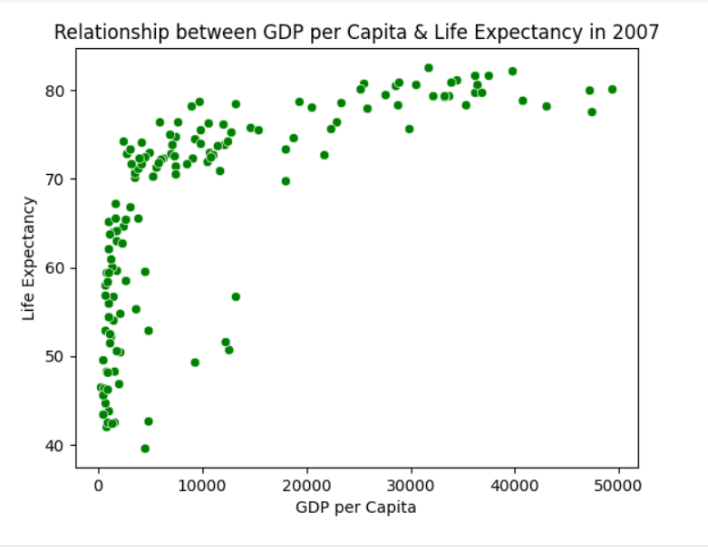

Answer: Yes, there is a noticeable trend and positive correlation between GDP per capita and life expectancy. As GDP per capita increases, life expectancy also tends to increase.  
This means that people living in wealthier countries usually live longer lives compared to those in poorer countries.

This can be happens for the following reasons:

* Better Healthcare: Richer countries can afford hospitals, doctors, and medicines.
* Good Nutrition: People in wealthier nations have better access to healthy food.
* Clean Water & Sanitation: Prevents many diseases and infections.
* Education & Awareness: Educated populations follow better hygiene and health practices.
* Lower Infant Mortality: More resources help reduce deaths at birth or early age.

Observation from the Graph:

In the low GDP range, small increases in income show a big jump in life expectancy.

In the high GDP range, the curve flattens — life expectancy rises slowly or stays stable even if GDP keeps increasing.

Conclusion: There is a strong positive correlation between GDP per capita and life expectancy, especially for poorer countries.  
However, in very rich countries, more money doesn’t always mean a longer life — other factors like lifestyle also come into play.

1. Compare the average GDP per capita for each continent in the year 2007. Use a bar chart for this comparison.

Subjective Question: Why is the average GDP per capita for Oceania higher than the Americas even though the Americas have more countries?

Answer: The average GDP per capita for Oceania is higher than that of the Americas because Oceania includes only a few very wealthy countries like Australia and New Zealand. In contrast, the Americas include both rich countries (like the USA and Canada) and many poorer countries in Central and South America. These lower-income countries bring down the overall average, even though the region has more countries.

1. Compare the life expectancy and GDP per capita of Afghanistan (a country known for its historical conflicts) and Switzerland (representing a peaceful and economically prosperous country) using the dataset provided.

* Firstly, for the year 2007, use a bar chart to directly compare the life expectancy and GDP per capita between these two countries.
* Then, create two separate line graphs to show the trends of these two metrics over all available years in the dataset for both countries.

Subjective Question: What differences do you observe in terms of life expectancy and economic development? How might the stability or instability of a country influence these key metrics over time? Analyze the data through these visualizations and discuss your inferences.

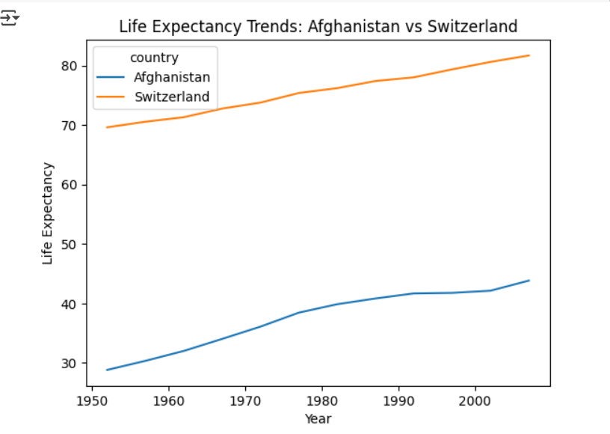

Answer: Based on the visualizations comparing **Afghanistan** and **Switzerland**, we can draw the following conclusions:

* Differences in Life Expectancy (2007):

Afghanistan: ~43 years

Switzerland: ~81 years  
Switzerland’s life expectancy is nearly double that of Afghanistan.

* Differences in GDP per Capita (2007):

Afghanistan: Very low (under $1,000)

Switzerland: Over $30,000  
Switzerland’s economic output per person is significantly higher.

**Trend over Time:**

Switzerland: Shows a steady upward trend in both GDP per capita and life expectancy over the years.

Afghanistan: Although there's some improvement, the growth is slow and irregular, especially in life expectancy.

**Analysis & Inferences:**

Political & Economic Stability: Switzerland’s long-standing peace, strong institutions, and economic policies contribute to better healthcare, education, and infrastructure, all of which support higher life expectancy and economic growth.

Conflict & Instability: Afghanistan has faced decades of war and instability, which have hindered development, limited access to healthcare, and reduced public investment, keeping both life expectancy and GDP per capita low.

**Conclusion**: The visual comparison shows a clear correlation between a country’s stability and its human development. Countries with peace and strong governance (like Switzerland) tend to have better life expectancy and economic outcomes, while conflict-ridden regions (like Afghanistan) struggle on both fronts.